Testimonials for Ecourse

I was surprised at all my son could learn with the right teaching methods.  He is very active and has a short attention span but with these methods he was on task and engaged.  It really makes a difference when the methods are appropriate to the age of the child.  Now I know the right way to work with my child.

Elisa, mother of four year old

Unique Teach taught me how to work with my first grader with his reading comprehension. He was reading at a high level but comprehending at a much lower level. He was being tested on his comprehension at school and they let me know about this problem, but the issue lingered.  Ms. Mia has specific techniques that fix situations such as these and they were effective in raising my son’s level of reading comprehension. I recommend her system to any parent that has a child who needs help in elementary school.

Tien, mother of first grader

Testimonial Slider

Justine’s testimonial 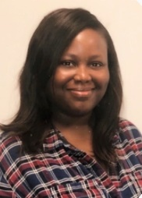

Mia Shimaj’s teaching methods are a breath of fresh air. Her teaching methods are innovative and effective. I have witnessed children use her methods and become a strong and confident learners. I’m excited and can’t wait to use her methods on my child. Her teaching methods should be used in all daycares and schools.

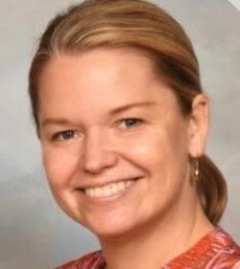Testimonial Reading App

Our son Henry, age 8, struggled quietly with school, specifically with reading and writing words. It wasn’t until we were introduced to Unique Teach that we realized that Henry had been memorizing words and interpreting pictures, rather than sounding out words. Ms. Mia’s phonics method doubled Henry’s scores in both reading and writing. Not only did Henry’s scores improve, he gained confidence and now takes the lead to do homework and participate in class. Henry is a happy child at school due in part to Ms. Mia.

Mary Ellen, mom of second grader

a

Testimonial Slider: Olivia:

 Even though we were told by our daughter’s school that she was reading at grade level, we knew something wasn't right. Sure she knew sight words and yes, she could even "read" short stories that were given to her at school but she couldn't truly read. She was unable to read very simple stories at home or just words that we would see on packages or doors for example. She had troubles even sounding out the simplest of sounds and/or words. Ms. Mia was quickly able to identify her weaknesses and began teaching her. My daughter is now able to decode words and truly read. She is even reading above grade level now and we are still choosing to stick with Ms. Mia because we have more faith in her teaching techniques than in that of our local school.

